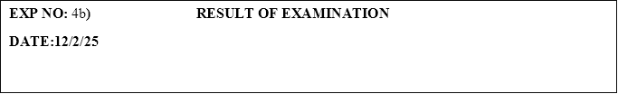

**PROGRAM:**

#!/bin/bash

# Read the file line by line

while read -r line

do

    # Split the line into an array

    arr=($line)

    # Get the student's name

    name=${arr[0]}

    # Get the marks of the student

    marks=${arr[@]:1}

    # Initialize a variable to track fail status

    fail=false

    # Check if any of the marks is less than 45

    for mark in ${marks[@]}

    do

        if [ $mark -lt 45 ]; then

            fail=true

            break

        fi

    done

    # Print the pass/fail status based on the condition

    if [ "$fail" = true ]; then

        echo "$name FAIL"

    else

        echo "$name PASS"

    fi

done < students.dat

**OUTPUT:**

BEN FAIL

: integer expression expected0

TOM PASS

: integer expression expected0

RAM PASS

: integer expression expected7

JIM PASS